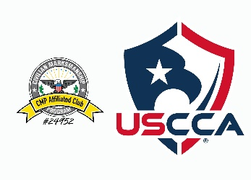 RIMFIRE FALL PISTOL/REVOLVER OR RIFLE LEAGUE
PISTOL TARGET THREE (3)
RIFLE TARGET THREE (3)
PURCHASE FROM PRO ARMAMENT
BE SURE PRINT ON TARGET:
RIMEFIRE RIFLE LEAGUE TARGET One (1) Full Name: _____________________________
Rifle @ 16.5 yards Iron / 25 yards Optic Date: _____________
Pistol @ 10 yards Iron / 16.5 yards Optic Week Match #: _______
Signature: _______________________________

